UTILIZATION OF INSTAGRAM SOCIAL MEDIA IN HEALTH PROMOTION ACTIVITIES AT HASAN SADIKIN HOSPITAL BANDUNG
Yustikasari , Renata Anisa, Retasari Dewi, Fajriani Ananda
Public Relations Study Program, Faculty of Communication Sciences, Padjadjaran University
Jl. Raya Bandung – Sumedang, KM. 21 Jatinangor 45363
Email : yustikasari@unpad.ac.id, fajriani.ananda7404@grad.unri.ac.id

Abstract Hospitals must carry out Hospital Health Promotion. By using social media, hospitals can convey various health information to patients, patients families, and society. This study aimed to determine the use of Instagram social media in the Health Promotion installation at Hasan Sadikin Hospital, Bandung. Data collection techniques used are interviews, observation, and documentation studies. The method in this research is descriptive and qualitative. The study results: first, the Health Promotion Installation of Hasan Sadikin Hospital Bandung has used Instagram well to convey health information. Second, the health promotion content presented on social media accounts is divided into 4 (four): announcement content, health promotion content, event content, and health day commemoration content. The conclusion of the research is Health Promotion Hasan Sadikin Hospital has made content management well, but what can be improved is the objective, message, and timeline of posting frequency.
Keywords: Utilization of Social Media, Instagram, Hospital Health Promotion

INTRODUCTION

Hospitals are expected to be committed to integrated and sustainable health promotion. Health promotion is scheduled to play a significant role in reorientating health services. In Permenkes 2018 concerning the implementation of hospital health promotion, hospitals must organize Hospital Health Promotion (PKRS) following the principles of a healthy, equitable, independent, inclusive and sustainable model. [1]
Health promotion is how people can better control, maintain and improve their health. Usually, this process is carried out by health workers by providing home care or home visits to the community or health education through counseling in the community and villages. This health promotion is not only communicated with theory but also with demonstrations regarding the importance of health maintenance or disease management. This demonstration must be carried out because the level of understanding of each society is different.
Hospital Health Promotion (PKRS) applied in hospitals must have regulations on implementing health promotion and conducting health promotion assessments for patients, patients families, hospital staff, hospital visitors, and the community around the hospital. In addition, hospitals are also required to intervene in health promotion and monitor health promotion assessments that have been carried out.
Hospital Health Promotion (PKRS) is not only valid in Indonesia but throughout the world. The World Health Organization (WHO), through the Collaborative Center for Health Advancement in Health and Care, emphasizes that hospitals provide health promotion and disease prevention services in providing medical services. Implementing health promotion in hospitals requires cooperation to support an integrated system. Collaboration with various parties is crucial, so health promotion can be carried out optimally and sustainably.
Hasan Sadikin Hospital (RSHS) Bandung, located on Jl. Pasteur no. 38 has become a Class A Hospital, the Best Referral Hospital (Top Referral Hospital) in West Java, a National Referral Hospital, and a Teaching Hospital with Quality and Competitiveness since 2019. Some excellent facilities owned by RSHS include assisted reproductive technology/medicine, cardiology services; oncology and infectious disease services; and kidney transplant services. Hasan Sadikin Hospital has 21 specialist health services and 133 sub-subspecialty health services. Hasan Sadikin Hospital Bandung already has a Health Promotion Installation Unit headed by dr. Puspita.
The Health Promotion Installation at Hasan Sadikin Hospital was established in 2012, where the content consists of Health Promotion, Marketing, and Community Complaints. In 2013 the Public Complaints subdivision joined the Public Relations Installation after a meeting with the Ministry of Health. In contrast, in the Health Promotion Installation, the contents consisted only of health promotion and marketing.
Health Promotion Activities in early 2020, before the Covid-19 pandemic, as stated by the Head of the Health Promotion Installation of Hasan Sadikin Hospital, were still carrying out Health Promotion activities directly by providing visits and guidance to community health centres (Puskesmas), health facilities under Hasan Sadikin Hospital Bandung and directly to the community who focused on a tiered basis from Geriatrics ( a branch of medical science that focuses on the treatment, diagnosis, and prevention of diseases and health disorders that affect the elderly), TIBI (Mycobacterium tuberculosis – the cause of TB / TB infection that secretly and silently eats away at the lungs and other organs of the body in children and adults in cities and villages), HIV ( human immunodeficiency virus) and Prolanis (Chronic Disease Management Program). Routine activities carried out during the Covid-19 pandemic are conducting on-site counselling at radio and television talk shows, training on personnel at public health centre (puskesmas) regarding SWAB, and information about medicines from pharmacies which are carried out online.
In meeting the standards of Health Promotion activities at Hasan Sadikin Hospital Bandung, the Head of the Health Program at Hasan Sadikin Hospital Bandung meets the program that the hospital installation department can implement. One of them is to take advantage of the use of Instagram social media. The development of information technology through digital media has brought new concepts to the world of communication. The idea is how businesses, governments, organizations, and individuals use and leverage social media. One of the most used social media is Instagram [2]. Instagram Social Media was first launched in 2010 and reported by Napoleon Cat. Instagram social media has been used by as many as 61,610,000 throughout Indonesia[2].
Health Promotion activities at Hasan Sadikin Hospital utilize social media because social media has several advantages. Instagram social media is multiplying now because by using photo and video posting services, this social media can be used not only as an entertainment medium but also widely used by many stakeholders such to sell products as well as promote health information in the community, being the most important thing that Instagram social media has.
From the results of the study [3] that Instagram is a photo and video-sharing social media application that allows users to take photos, apply digital filters, and share them on different social media services, including similar Instagram. Up to 5 million Indonesians actively use Instagram and are recognized as the top Instagram story creators in the world. This number increased from active users at the beginning of 2016 to only 22 million. Indonesia is the largest Instagram community in Asia-Pacific, as well as one of the largest markets in the world, with a total of 700 million monthly active users.
From the research conducted by [4], the presence of social media can improve the organizational and individual image of health workers, expand the reach of organizations, and support changing consumer demand for health services with appointments in medical facilities (Kotsenas, 2018). Hospitals can use social media as an advertising tool, helping consumers understand their treatment options and get feedback on the hospital's services. For hospital marketing in the digital age, the presence of social media can improve the corporate image of hospitals and individual medical staff, especially healthcare workers who provide online services and access to patients, and expand the organization's reach. Thus, social networks are mainly used to share health education information and as a forum for socialization and community between parties who care about or have specific health problems. The ease of access and availability of social media also drives this behavior among the public, patients, and healthcare providers.
Hasan Sadikin Hospital uses and utilizes Instagram social media specifically to educate and provide information to the public about health. Information aimed at educating the people made by the Health Promotion team includes proper oral drug administration, stimulating oral muscles in babies, feeding using intervals, deep breath and coughing exercises, getting to know scoliosis, and other health education information.
Hasan Sadikin Hospital's Health Promotion Instagram social media account is @promkes.rshs. The Hasan Sadikin Hospital Promkes Installation utilizes Instagram Social Media, and a team of 3 people manages its management. The picture below is an example of health education content created by the Instagram account @promkes.rshs.

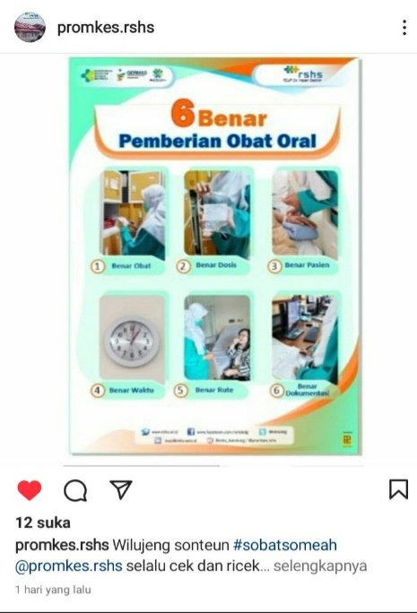
Figure 1: Oral Drug Administration
Health Education Content of Hasan Sadikin Hospital Health Promkes

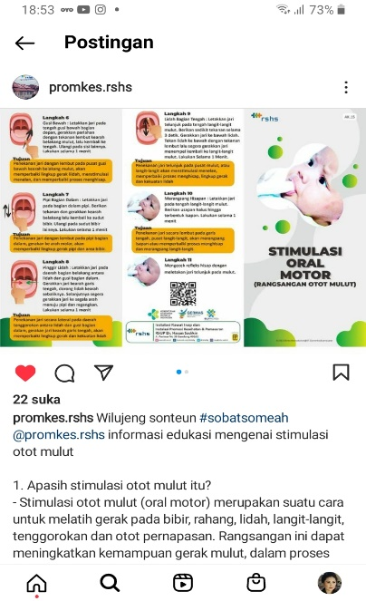
Figure 2: Oral Motor Stimulation in Infants
Health Education Content of Hasan Sadikin Hospital Health Promkes

The use of Instagram social media by the Hasan Sadikin Hospital Bandung Health Promotion installation has been used for about 2 years since 2020. The service and use of social media are optimized considering the conditions since 2 years ago with the requirements of the Covid-19 pandemic; health promoters can't convey information messages directly / face-to-face. For this reason, using Instagram social media to communicate health information is the right choice because social media has several advantages.

METHOD

The research method used in this study uses qualitative research methods. Creswell (2008) [5] defines it as an approach or research to find and understand a central phenomenon. To understand the significant phenomenon, researchers interview participants or study participants by asking general and fairly broad questions. The information submitted by the participants is then collected. The information is usually in oral or written form. Data in the form of words or text is then analyzed. The analysis results can be descriptive or descriptive, or it can be a topic. From these data, researchers make interpretations to capture their most profound meaning. Then, the researcher performs a personal reflection (self-reflection) and explains it with research that other scientists have done before. The final result of the qualitative study is presented as a written report.
As stated by [5], Qualitative research methods do not use detailed questions in quantitative methods. The question usually starts with the general and then goes down in detail. This is generally because researchers provide the amplest opportunity for participants to express their thoughts and opinions without being limited by the researcher. Such researchers later refined the rich information of the participants. This is because it emphasizes the importance of participants' knowledge being the primary data source. The term "participant" is used because of the study participant's active role in providing information. This method differs from the quantitative method of calling them "responders" in that its function is nothing more than answering or responding to questions prepared by the researcher and their responses.
Qualitative methods treat participants as subjects, not objects. This is where participants come in handy because their information is of great help to the researcher. This research method gives participants considerable space. They avoid objections from researchers, who answer only the prepared questions and select ready-made responses.
This study tries to look at the real-life events experienced by the subjects of this study holistically and meaningfully. In simpler terms, this study aims to provide an overview and explanation of the implementation of the use of social media regarding health information at Hasan Sadikin Hospital Bandung, West Java Province.

RESULTS AND DISCUSSION
Health communication in hospitals is needed to increase awareness about a clean and healthy lifestyle. Health communication is intended to provide public information or messages about health. Health communication makes a practical contribution to health promotion and disease prevention in a particular area. In addition to promoting health, it will help people learn various things about existing health information or messages, health problems, and the management of physical and non-physical. A strategy is needed before carrying out health promotion to achieve the goal of health promotion. Health promotion strategies include advocacy, social support, and community empowerment. Public hospitals and mental hospitals need to carry out health promotion with these three strategies so that people instil a sense of clean and healthy living.
Hasan Sadikin Hospital (RSHS) Bandung, located on Jalan Pasteur No. 38, has become a Grade A Hospital, the Best Referral Hospital (Top Referral Hospital) in West Java, a National Referral Hospital, and a quality and competitive Hospital since 2019. The Hospital Health Promotion Installation Unit (PKRS) at Hasan Sadikin Hospital Bandung has delivered education about health on health promotion activities it carries out by using social media Instagram.
The social media owned by the Health Promotion installation at Hasan Sadikin Hospital Bandung is Instagram, with the account name @promkes.rshs. The @promkes.rshs account is a social media account for the Health Promotion and Marketing Installation of Hasan Sadikin Hospital Bandung. Health-related information that must be known to patients, patients' families, and the public, in general, is routinely conveyed through the Instagram social media account @promkes.rshs.
The Instagram social media account @promkes.rshs has been owned since September 1, 2020, and was present during the COVID-19 pandemic. The initial educational information post conveyed on the account was health education content with the title: "don't forget to wear a mask." The information or content is created because it is related to adapting new habits that must continue to be conveyed to the community so that they remain accustomed while maintaining health protocols that are useful for themselves and others. The picture posted on Instagram was taken from the web Promosi Kesehatan Kementrian Kesehatan Republik Indonesia. As is known, the Covid-19 pandemic has succeeded in changing our daily routines at home, school, work, on the street, and anywhere. This seems to make people finally seem helpless because of the movements restricted by Covid-19, which makes community activities inefficient and impacts the economic problems of families, communities, regions, and countries. The following picture is related to health education information that must be done by the community as a whole in facing new habits, namely not to forget to use masks.

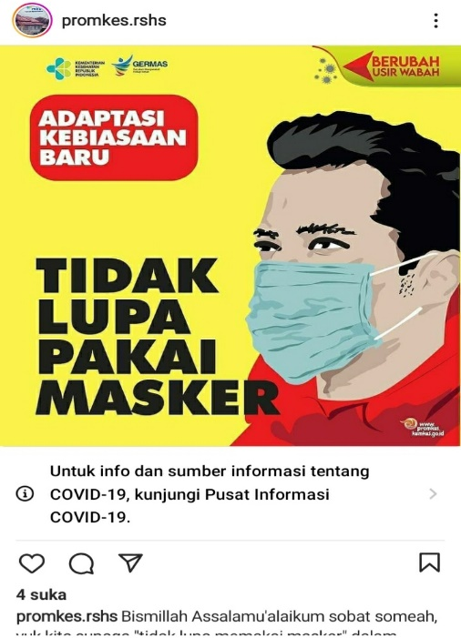
Figure 3: Don't Forget to Wear a Mask
Health Education Content of Hasan Sadikin Hospital Health Promkes

The implementation of health promotion (Promkes) at Hasan Sadikin Hospital Bandung, according to the Head of the Health Promotion Installation of Hasan Sadikin Hospital Bandung, dr. Puspita, the form follows Permenkes Number 44 of 2018 concerning the Implementation of Hospital Health Promotion (PKRS), which is in the form of installation. According to him, the number of Promkes personnel at Hasan Sadikin Hospital is still not following the hospital's criteria, namely the type/class of the hospital. The number of personnel in the Promkes Installation is only 3, with 1 person as a health promoter. The Promkes activities it has carried out as stated in the Permenkes related to counselling to the community, community empowerment, and advocacy.
The lack of human resources in the implementation of health promotion is as stated in the study [6] that the availability of resources, especially human resources, is not appropriate according to the 2018 Minister of Health Regulation that a PKRS human resources manager must have health promotion skills and have received technical training in PKRS management, to be in line with the principles of promotion health. As stated in the theory of 'Edward III, if the existing human resources are inadequate, this can affect the successful implementation of the program. The availability of a budget is also one of the fundamental factors as a supporting resource to carry out an activity that includes health promotion activities. The implementation of hospital health promotion certainly cannot be carried out properly if it is not accompanied by facilities and infrastructure that can support the successful implementation of PKRS activities, such as lack of resources in the form of staff capacity, time allocation, strategy, the critical role of health-oriented policies and the availability of funds.
The use of social media in hospitals, especially regarding health information, such as research conducted by [7] that social media is included in one of the media that helps people to get information about many things, and this social media is easily accessible to all circles. Well-known social media include Twitter, Facebook, emails, Instagram, etc. The use of social media in Indonesia is now widespread and social media is now used as a way to improve health. One is done by the Tangerang Regency Regional Hospital, which uses social media to improve hospital health.
It is also mentioned from the results of research conducted by [7] that social media positively impacts people's preventive behavior during the COVID-19 pandemic in China. It is an important indicator of health promotion to encourage people to take emergency health care measures. It is estimated that more than 90% of adults in the United States have at least one social media account, with an average daily use of 2 to 7 hours. When testing the scope, the study found that 23 studies reviewed (5%) showed that the Association's social networks were the central or only channel used to promote sexual health.
The reason for the use of Instagram social media by the Kesehatan Promotion installation at Hasan Sadikin Hospital Bandung, as conveyed by the Head of PKRS Installation at Hasan Sadikin Hospital, is to reach a broad target audience, namely the general public, because there are several facilities on the social media that can be optimized. Such as social media content is published in the form of images, videos, and audio and utilizes the features available on each platform, such as IGTV and IG Story on Instagram. This presents an opportunity that is quite important for hospitals to be more comprehensive in delivering various educational content because it can reach a wider audience. In addition, because through Instagram social media, the content conveyed about health activities held such as talk shows on the radio, on television or webinars, seminars, and so on, is not necessary for participation from users in social media to be involved in these activities so that it can provide opportunities to develop and strengthen relationships. The community also creates a group identity, especially a group that is interested in various things related to health.
The rapid development of social media in the last 15 years has led to the emergence of health services and information that involve participation among healthcare providers and patients. The ease of access to internet devices allows everyone to freely access health information from various sources, mainly social media so that there are places for communities to gather or provide medical information, as stated by [4] in his research.
As for the content category on Instagram social media, @promkes.rshs is divided into 4 categories: announcement category, event category, health day commemoration category, and health promotion information category.
Here is an example of an announcement content category on Instagram social media @promkes.rshs :
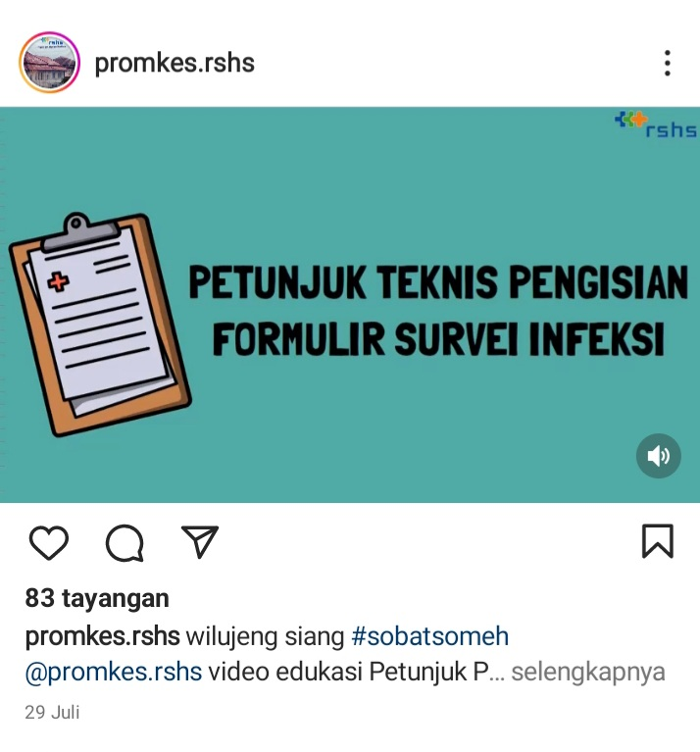
Figure 4: Announcement Content Category
Image of Health Education Information for Hasan Sadikin Hospital Health Program
The announcement contains an educational video of technical instructions for filling out infection survey forms at risk of infection prevention by Rani Dwi Agustin., S.Kep., Ners. The video, which is 14 minutes and 55 seconds long, provides detailed information about the filling instructions and falls into the announcement content category.
Next is an example of an event category on the @promkes.rshs Instagram account:
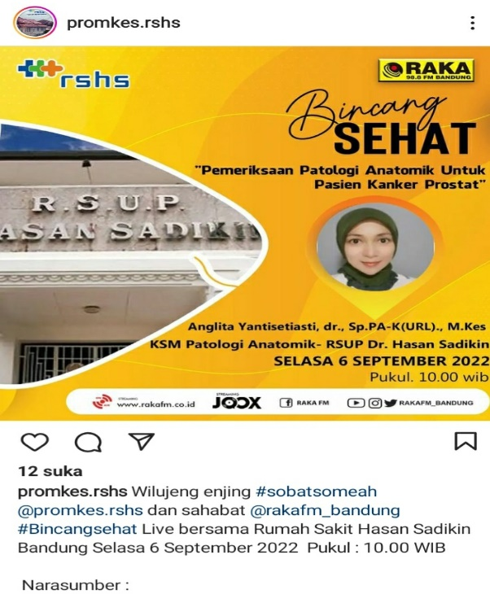
Figure 5: Event Content Category
Health Education Information for Hasan Sadikin Hospital
The event content category contains information about the talk show event, which was carried out live via Youtube Radio Raka FM with a resource person for one of the doctors at Hasan Sadikin Hospital Bandung. The talk show activity is a collaboration between the Health Promotion Installation section of Hasan Sadikin Hospital Bandung and Raka FM Bandung radio. In this activity, the listeners can interact and ask questions directly via SMS or WA Radio Raka FM Bandung. This talk show on the radio is also one of the routine activities carried out by the Health Promotion installation to provide information and education to the public about health.
Next is the content of the commemoration of health day on Instagram @promkes.rshs:
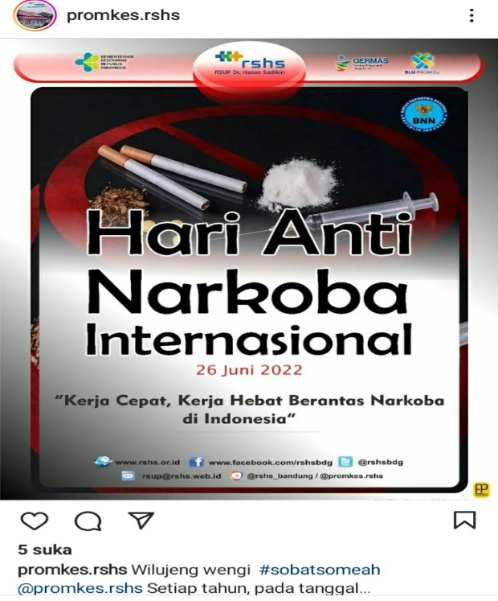
Figure 6: Health Remembrance Day Categories
Health Education Information for Hasan Sadikin Hospital
The Health Memorial Day content category on the @promkes.rshs account is one of the international anti-narcotics day content that falls every June 26. On that day, the world community opposed the abuse of drugs as well as the trade in illegal drugs. The Day commemoration is used by the Health Promotion installation of Hasan Sadikin Hospital as momentum to increase public awareness, knowledge, and understanding of what illicit drugs can cause.
The Last Content Category that is the main focus is health promotion content. One example of content loaded in the @promkes.rshs account is as follows:

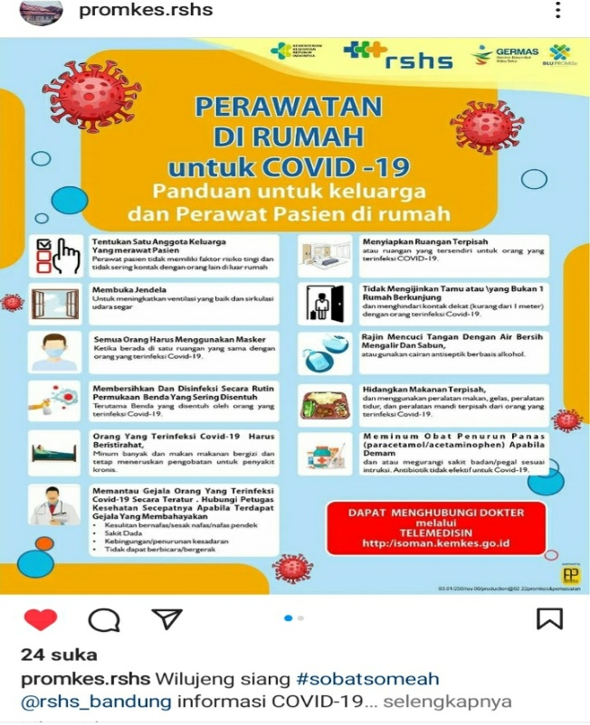
Figure 7: Health Promotion Content Category
Health Education Information for Hasan Sadikin Hospital

The Health Promotion Content category contains educational information content that aims to provide knowledge and insight to the general public. The picture above includes guidelines and steps regarding home care for Covid 19 for families and patient nurses at home.
The Instagram account @promkes.rshs is quite active in conveying health information with the 4 categories described above. As of August 22, 2022, this account has posted 1085 posts of content with various categories. The type of content is conveyed in multiple forms, such as posters, images, and audio-visual / video. This makes it easier for the target to understand the content expressed in the social media account better.
The effective use of Instagram social media is one of the indicators that health promotion workers must be proficient and able to take advantage of the development of information communication technology properly. This is stated from the study [8] results that the attitudes and skills of health promotion practitioners, environmental factors, and the attitudes and lifestyles of patients and their families are also very supportive of the effectiveness of treatment and treatment carried out in hospitals. Standard Operating Procedures for Implementing Health Promotion in Hospitals are stipulated in the 2012 Minister of Health regulation concerning Technical Guidelines for Health Promotion in Hospitals. The Minister of Health clearly explained the importance of health promotion in all non-business hospital units and health workers who work as extension workers or houses in providing education services around health.
Through the Hospital Health Program (PKRS), health care promotors can develop understanding and knowledge in healthy visitors, patients, and their families regarding health prevention and treatment. In addition, PKRS also seeks to increase awareness and care of patients, patients' families, and hospitals. Visitors play an active role in efforts to cure and prevent disease. This proves that PKRS is an essential program and cannot be separated from hospital services. After all, it supports the growth and development of hospitals because it can improve the degree of medicine and public health services and make patients, family patients, and visitors feel satisfied and comfortable with the hospital services they choose.
The selection of social media as a medium for conveying health information at Hasan Sadikin Hospital Bandung is carried out by the Hospital Health Promotion Installation, one of the health promotion strategies carried out, because hospitals must have a specific strategy in conveying information related to health promotion. From the research results [9], health promotion aims to socialize health programs to realize a new Indonesian society that can live a clean and healthy culture and hope that the community can participate directly in health service activities.
The use of social media in conveying health promotion information is carried out because there are several advantages that I have, including being able to reach a broad audience, being able to get information quickly, being a trusted media, and content that is actively posted through social media will make it easier for the account to grow better and better. This makes health promoters through the PKRS unit strive to provide services in a normal manner to the general public so that there is a change in the knowledge and attitudes of patients, patient's families, and clients towards the various health information provided.

CONCLUSION
The Instagram account of the Health Promotion Installation @prokes.rshs, owned by Hasan Sadikin Hospital Bandung, already has a balanced amount of information between health information related to announcement content, health event content, health warning content, and health promotion content. Instagram is one of the social media used by health promotion installations to convey health information.
Features in social media are utilized by @promkes.rshs accounts, namely the photo upload feature and videos, by adding photo captions/ captions, hashtags (#), the use of IG Story, and IG Live. It is hoped that using these features can further optimize the use of Instagram social media.
The thing that must be considered to increase the use of social media is to determine the specific objective or purpose of the health information to be conveyed, the message or content along with a good photo caption to support the message expressed, and the timeline or frequency of posts that should be done on a scheduled basis.

ACKNOWLEDGMENTS
A thank you to Universitas Padjadjaran as a funder in the implementation of this research. Universitas Padjadjaran has also helped and provided opportunities and permission for the authors to perform this research. Also, all parties are pleased to provide assistance and convenience.

BIBLIOGRAPHY

[1] Y. Ying and D. Park, "No 主観的健康感を中心とした在宅高齢者における 健康関連指標に関する共分散構造分析Title," 2018. [Online]. Available: https://promkes.kemkes.go.id/download/fpkj/files7645244 TAHUN 2018.pdf.

[2] T. dan Y. Jasmine, “Editor In Chef / Pelaksana,” J. Inov. Penelit., vol. 1, no. 11, pp. 2229–2310, 2021.

[3] F. A. Sari, N. P. Sari, and Nabila, “Health Promotion Breast Self Examination (BSE) Using Instagram in Non Medical Student of Andalas University,” Media Kesehat. Masy. Indones., vol. 15, no. 3, pp. 253–263, 2019.

[4] A. Tri Wijayati, A. Drea, F. Kusumasari, and R. Selvia, “Jurnal ARSI/Volume 6 Nomor 3 130 Penggunaan Media Sosial di Rumah Sakit: A Systematic Review The Use Of Social Media in Hospital : A Systematic Review,” J. ARSI, vol. 6, no. 3, pp. 130–139, 2020.

[5] J. Raco, “Metode penelitian kualitatif: jenis, karakteristik dan keunggulannya,” 2018.

[6] T. I. Ramadhona, E. Budianti, and N. S. A. Hermawan, “Analisis Implementasi Promosi Kesehatan Rumah Sakit,” J. Ilm. STIKES Kendal, vol. 11, pp. 889–896, 2021.

[7] L. Vionita and D. Prayoga, “Penggunaan Media Sosial selama Pandemi Covid-19 dalam Promosi Kesehatan di Rumah Sakit Kabupaten Tangerang,” Media Kesehat. Masy. Indones., vol. 20, no. 2, pp. 126–133, 2021.

[8] M. A. Suhada and R. Q. Ain, “Pelaksanaan PKRS di RUmah Sakit Berdasarkan Telaah Jurnal,” Muhammadiyah Public Heal. J., vol. 1, No. 2, pp. 155–17, 2021.

[9] R. Gayatri Setyabudi and M. Dewi, “Analisis Strategi Promosi Kesehatan dalam Rangka Meningkatkan Kesadaran Hidup Sehat oleh Rumah Sakit Jiwa Daerah Dr. RM. Soedjarwadi Provinsi Jawa Tengah,” J. Komun., vol. 12, no. 1, pp. 81–100, 2017.

