Utilization Of Instagram Social Media In Health Promotion Activities At Hasan Sadikin Hospital Bandung

Yustikasari¹, Renata Anisa², Retasari Dewi³, Fajriani Ananda⁴
^{1,2,3,4} Public Relations Study Program, Faculty of Communication Sciences, Padjadjaran University, Banudng, Indonesia
Email: yustikasari@unpad.ac.id , fajriani.ananda7404@grad.unri.ac.id
Article Info

Article history
Received date: 2022-08-19
Revised date: 2023-02-06
Accepted date: 2023-02-07

Abstract

Hospitals must carry out Hospital Health Promotion. By using social media, hospitals can convey various health information to patients, patient's families, and society. This study aimed to determine the use of Instagram social media in the Health Promotion installation at Hasan Sadikin Hospital, Bandung. Data collection techniques used are interviews, observation and documentation studies. The method in this research is descriptive qualitative. The study results: first, the Health Promotion Installation of Hasan Sadikin Hospital Bandung has used Instagram social media well to convey health information. Second, the health promotion content presented on social media accounts is divided into 4 (four): announcement, health promotion, event, and health day commemoration. The conclusion of the research is Health Promotion at Hasan Sadikin Hospital has made content management well, but what can be improved is the objective, message, and timeline of posting frequency.
Keywords:
Utilization of Social Media; Instagram; Hospital Health Promotion

Abstrak
Rumah sakit harus menyelenggarakan Promosi Kesehatan Rumah Sakit. Dengan memanfaatkan media sosial dengan baik, rumah sakit akan dapat menyampaikan berbagai informasi kesehatan pada pasien, keluarga pasien juga masyarakat secara umum. Tujuan penelitian ini adalah untuk mengetahui pemanfaatan media sosial Instagram pada instalasi Promosi Kesehatan di RS Hasan Sadikin Bandung. Teknik pengumpulan data yang digunakan adalah wawancara, observasi dan studi dokumentasi. Metode dalam penelitian ini adalah deskriptif kualitatif . Hasil penelitian: pertama, Instalasi Promosi Kesehatan Rumah Sakit Hasan Sadikin Bandung telah menggunakan media sosial instagram dengan baik untuk menyampaikan informasi kesehatan; kedua, konten promosi kesehatan yang di sajikan pada akun media sosial terbagi menjadi 4 (empat) yaitu : konten pengumuman, konten promosi kesehatan, konten event serta konten peringatan hari kesehatan. Simpulan dari penelitian adalah Promosi Kesehatan Rumah Sakit Hasan Sadikin telah membuat pengelolaan konten dengan baik namun hal yang dapat di tingkatkan adalah objektif, pesan, dan timeline frekuensi posting.
Kata Kunci:
Pemanfaatan Media Sosial; Instagram; Promosi Kesehatan Rumah Sakit

INTRODUCTION
Hospitals are expected to be committed to integrated and sustainable health promotion. Health promotion is expected to play a significant role in reorientating health services. In Permenkes Number 44 of 2018 concerning the Implementation of Hospital Health Promotion, hospitals must organize PKRS according to the principles of a healthy, equitable, independent, inclusive and sustainable model. [1]
For every two Indonesians, there is a disease for which there is no known cure. Although the hospital has taken steps to promote the disease and its treatment, its status as a health service is not sufficient to disseminate health information through newsletters, books or other counselling materials provided by the hospital. For specialists or medical organizations, many factors are unknown. Like any disease, technology has advanced to a new level, enabling anyone, anywhere, anytime, to access information quickly and cheaply. When using online media, is one of the fastest media that has Internet reliability is a technological phenomenon [2].
Health promotion is a process by which people can better control, maintain and improve their health. Usually, this process is carried out by health workers by providing home care or home visits to the community or health education through outreach in communities and villages. This health promotion is communicated with theory and demonstrations about the importance of maintaining health or overcoming the disease. This demonstration must be carried out because the level of understanding of each community is different.
Hospital Health Promotion Standards (PKRS) applied in hospitals must have regulations regarding how to implement health promotion and conduct health promotion assessments for patients, patient families, hospital staff, hospital visitors and the community around the hospital. In addition, hospitals are also required to intervene in health promotion and monitor health promotion assessments that have been implemented.
Hospital Health Promotion (PKRS) does not only apply in Indonesia but throughout the world. The World Health Organization (WHO), through the Collaborative Center for Health Advancement in Health and Care, emphasizes that hospitals provide health promotion and disease prevention services in providing medical services. Implementation of health promotion in hospitals requires cooperation to support an integrated system. Collaboration with various parties is essential, so health promotion can be carried out optimally and sustainably.
Hasan Sadikin General Hospital (RSHS) Bandung, located on Jl. Pasteur, no 38, has become a Class A Hospital, the Best Referral Hospital (Top Referral Hospital) in West Java, National Referral Hospital and Teaching Hospital with Quality and Competitiveness since 2019. Some excellent facilities owned by RSHS include assisted reproductive technology/medicine; cardiology services; oncology and infectious disease services; and kidney transplant services. RSHS has 21 specialist health services and 133 sub-specialist health services. Bandung Hasan Sadikin Hospital has a Health Promotion Installation Unit headed by dr. Puspita.
The Health Promotion Installation at Hasan Sadikin Hospital has been established since 2012, and the contents consist of Health Promotion, Marketing and Community Complaints. In 2013 the Community Complaints sub-section joined the Public Relations Installation. After a meeting with the Ministry of Health, the contents of the Health Promotion Installation only consisted of Health Promotion and Marketing.
Health Promotion Activities in early 2020, before the covid 19 pandemic occurred, as conveyed by the Head of the Promkes Installation at Hasan Sadikin Hospital, still carrying out Health Promotion activities directly by providing visits and coaching to the Public Health Center (Puskesmas), health facilities under Hasan Hospital Sadikin Bandung and directly to the community which is focused in stages from Geriatrics (a branch of medical science that focuses on handling, diagnosing, and preventing diseases and health problems that attack the elderly), TIBI (Mycobacterium tuberculosis - the cause of TB/TB infection which secretly and silently eats away at the lungs and other organs of children and adults in cities and villages), HIV (human immunodeficiency virus) and Prolanis (Chronic Disease Management Program). Routine activities carried out during the Covid-19 pandemic were conducting on-site counselling, talk shows on radio and television, training for personnel at the Public Health Center (Puskesmas) regarding SWAB, and information regarding medicines from pharmacies carried out online.
In fulfilling the standards for Health Promotion activities at Hasan Sadikin Hospital Bandung, the Head of Health Promotion at Hasan Sadikin Hospital Bandung, complied with the program that can be carried out by the Hospital installation department. One of them is to take advantage of the use of Instagram social media. The development of information technology through digital media has brought new concepts to the world of communication. The concept is how businesses, governments, organizations, and individuals use and utilize social media. One of the most used social media is Instagram. Instagram Social Media was first launched in 2010 by Napoleon Cat. Instagram social media has been used by as many as 61,610,000 throughout Indonesia.[3]
The use of social media in health institutions such as hospitals has become unavoidable, as stated in research. Social media is one of the resources used to help people get information and knowledge that is easy to get anywhere. Popular social media include Facebook, website, email, Instagram, Telegram, etc. According to hospitals use social media to promote health services and inform news about events organized by the hospital. According to, in 2019, 94% of hospitals used social media for marketing; in America, 94.41% of hospitals used Facebook as a marketing tool, and 50.82% used Twitter. In Western Europe, 67.0% of hospitals use Facebook for social media marketing and 18.1% for Twitter accounts.
In this digital world, the internet makes everything easy. According to information from the Association of Indonesian Internet Service Providers (APJII), Indonesia's most widely used means of communication and social media are on the island of Java. APJII also claims that most users are between 15 and 2 years old and use smartphones daily . According to news published by the Tribune, Indonesia is the fourth country with the most significant number of social media users [5]
Hasan Sadikin Hospital's Health Promotion Activities utilize social media because social media has several advantages. Social media Instagram has increased to date because by using photo and video posting services, this social media can be used not only as a medium of entertainment but also widely used for many stakeholders, such as selling products and promoting health information to the public. Become an advantage possessed by social media Instagram.
The use of social media Instagram has the facilities offered. Instagram is a place where users can view pictures or videos uploaded by friends, idols, influencers, artists, and other people they don't know. After viewing a photo or video, users can also comment on their feelings when viewing uploaded messages. Instagram users Jan H. Kietzmann, Kritopher Kermkens, Ian P. McCarthy and Bruno S. Silvestre, namely:
a. identity.
Instagram user identities, such as name, age, and gender.
b. Discussions
interactions between Instagram users.
c. Share
Share content posted on Instagram in the form of photos or videos.
d. presence
Knowing the location of each other's users through Instagram messages [5].
The results of research [6] show that Instagram is a photo and video-sharing social media application that allows users to take photos, apply digital filters, and share them on different social media services, including similar Instagram. Up to 5 million Indonesians actively use Instagram and are recognized as the top Instagram story creators in the world. This number has increased from active users in early 2016 to only 22 million. Indonesia is the largest Instagram community in Asia-Pacific, as well as one of the largest markets in the world, with a total of 700 million active monthly users.
Meanwhile, research [7] stated that Instagram is used to search for health information because "it can provide an opportunity for its users to disseminate health information as widely as possible and with a visually attractive display". Other reasons are "easy access to information" and "good value for seeking health information".
Research conducted by [8] shows that the presence of social media can improve the organizational and individual image of health workers, expand the organization's reach, and support changes in consumer demand for health services with appointments at medical facilities. Hospitals can use social media as an advertising tool, helping consumers understand their treatment options and get feedback about the hospital's services. For hospital marketing in the digital era, social media presence can improve the corporate image of hospitals and individual medical staff, especially health workers who provide online services and access to patients and expand the organization's reach. Thus, social networks are mainly used to share health education information and as a forum for outreach and community between parties who care about or have specific health problems. The ease of access and availability of social media also encourages this behaviour among the public, patients and healthcare providers.
Health promotion aims to influence a broad audience. Advertising can inform the public to shape people's behaviour. In this case, health promotion can use various communication and the internet to influence behaviour and increase awareness and knowledge about health problems, risks, and solutions. The goal is to improve and maintain health. [9]
Research conducted [10] says that health promotion, in general, is designed to empower individuals and communities to increase their ability to improve their health status. WHO defines the definition of health promotion: as "Health promotion is a process by which people can increase control and improvement of their health. To achieve complete physical, mental and social well-being, individuals or groups must be able to identify; and be aware of their wants, responding to needs and changing or dealing with the environment" .
Hasan Sadikin Hospital uses Instagram social media to educate and inform the public about health. Hasan Sadikin Hospital provides various health information to the public information aimed at educating the public created by the health promotion team, including administering oral medication correctly, stimulating the mouth muscles in infants, feeding using a feeding tube, deep breathing and practical coughing exercises, getting to know scoliosis and health educational information other.
Hasan Sadikin Hospital Health Promotion Instagram social media account, named: @promkes.rshs. The Hasan Sadikin Hospital Promkes Installation extensively utilizes Instagram Social Media, and its management is carried out by a team from this installation consisting of 3 people.
The image below is an example of health education content created by the Instagram account @promkes.rshs.

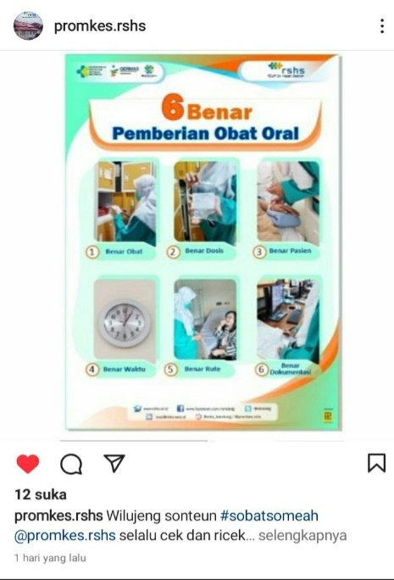
Figure 1: Administration of Oral Drugs
Hasan Sadikin Hospital Promkes Health Education Content

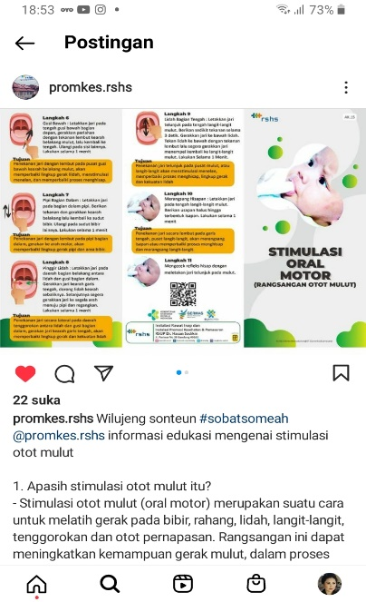
Figure 2: Oral Motor Stimulation in Infants
Hasan Sadikin Hospital Promkes Health Education Content

The use of Instagram social media by the Hasan Sadikin Hospital Bandung Health Promotion installation has been used for about two years since 2020. The use and utilization of this social media are optimized considering the conditions since two years ago with the condition of the Covid 19 pandemic; health promoters can't convey order information directly/face to face. For this reason, utilizing Instagram social media to convey health information is the right choice because social media has several advantages.

METHOD
The research method used in this study uses qualitative research methods. Creswell [11] defines it as an approach or research to find and understand a central phenomenon. Researchers interview participants or study participants to understand the central phenomenon by asking general and broad questions. Information submitted by participants is then collected, usually in oral or written form. Data in the form of words or text are then analyzed. The analysis results can be descriptive or descriptive or in the form of topics. From these data, researchers make interpretations to capture the most profound meaning. Then, the researcher conducts personal reflection (self-reflection) and explains it with research that has been done by other scientists before. The final results of the qualitative study are presented as a written report.
As stated, qualitative research methods do not use detailed questions like quantitative ones. The questions usually start with general and then go down and detail. This is generally because the researcher provides the most comprehensive opportunity for participants to express their thoughts and opinions without being limited by the researcher. Such researchers then refine the rich information from the participants. This is because it emphasizes the importance of participants' information being the data's primary source. The term "participant" is used because of the active role of the study participant in making the information available. This method is different from quantitative methods, which call them "responders" because their function is nothing more than answering or responding to questions prepared by researchers and their responses.
Qualitative methods treat participants as subjects, not objects. This is where participants come in handy, as their information is of great help to the researcher. This research method provides participants with a vast space. They avoided objections from researchers, who answered only prepared questions and selected pre-made responses.
This research tries to look at the actual life events experienced by the research subjects in a holistic and meaningful way. In simpler terms, this study aims to provide an overview and explanation of the implementation of the use of social media regarding health information at the Hasan Sadikin Hospital in Bandung, West Java Province.

RESULTS AND DISCUSSION
In hospitals, health communication is needed as one of the activities to raise awareness about clean and healthy lifestyles. Health communication is intended to provide information or messages about health to the public. Health communication contributes practically to health promotion and disease prevention in certain areas. In addition to promoting health, it will help people learn various things about existing health information or messages, health problems, and the management of health problems, both physical and non-physical. A strategy is needed before carrying out health promotion to achieve health promotion goals. Health promotion strategies include advocacy, social support and community empowerment. Public hospitals and psychiatric hospitals need to carry out health promotion with these three strategies so that people instil a sense of clean and healthy living.
Hasan Sadikin Hospital (RSHS) Bandung, located at Jalan Pasteur No. 38, has been a Grade A Hospital, the Best Referral Hospital (Top Referral Hospital ) in West Java, a National Referral Hospital and a quality and competitive Hospital since 2019. The Hospital Health Promotion Installation Unit (PKRS) at Hasan Hospital Sadikin Bandung has delivered education about health in health promotion activities through Instagram social media.
The social media owned and used by the Health Promotion installation at Hasan Sadikin Hospital Bandung is Instagram, with the account name @promkes.rshs. The @promkes.rshs account is a social media account for the Health Promotion and Marketing Installation at Hasan Sadikin Hospital, Bandung. Health-related information that patients, their families, and the general public should know is routinely conveyed via the Instagram social media account @promkes.rshs.
The Instagram social media account @promkes.rshs has been owned since September 1 2020 and was present during the COVID-19 pandemic. The initial educational information post conveyed on the account was health education content with the title: "don't forget to wear a mask". This information or content is created because it is related to adapting new habits that must continue to be conveyed to the community so that they remain accustomed while maintaining health protocols that are useful for themselves and other parties. The picture posted on Instagram social media was taken from the Health Promotion website of the Ministry of Health of the Republic of Indonesia. As you know, the Covid-19 pandemic has changed our daily routines at home, school, work, on the road and anywhere. This seems to have made the community seem powerless in the end because the movement was restricted by Covid-19, which made community activities inefficient and impacted the economic problems of families, communities, regions and the country. The following image is related to health education information that all people must carry out in dealing with new habits, namely, not to forget to wear a mask.

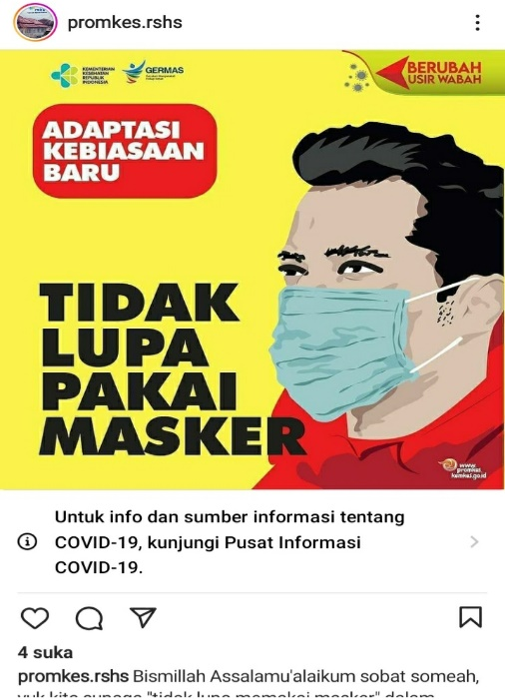
Figure 3: Don't forget to wear a mask
Hasan Sadikin Hospital Promkes Health Education Content

Implementation of health promotion (Promkes) at Hasan Sadikin Hospital in Bandung, according to the Head of Health Promotion Installation at Hasan Sadikin Hospital Bandung, Dr. The number of Promkes personnel at Hasan Sadikin Hospital, according to him, is still not following the hospital criteria, namely the type/class of the hospital. The number of personnel in the Promkes Installation is only 3, with one person as a health promoter. The Promkes activities have been carried out as stated in the Permenkes related to outreach to the community, community empowerment and advocacy.
The lack of human resources in the implementation of health promotion is as stated in research [12] that the availability of resources, especially human resources, which is not appropriate according to the 2018 Minister of Health Regulation that a PKRS human resource manager must have health promotion skills and have received training technical in PKRS management so that it is in line with the principles of health promotion. As conveyed in 'Edward III's theory, if the existing human resources are inadequate, this can affect the success of program implementation. Budget availability is also one of the essential factors as a supporting resource for carrying out an activity which includes health promotion activities. The implementation of hospital health promotion certainly cannot be carried out properly if it is not accompanied by facilities and infrastructure that can support the successful implementation of PKRS activities such as a lack of resources in the form of staff capacity, time allocation, strategy, the important role of health-oriented policies and availability of funds.
In line with research conducted by [13] that in health promotion activities in hospitals, human resources are needed as the basis for maximum efficiency, namely the Ministerial Regulation of the Republic of Indonesia No.004 of 2012 in the technical guidelines for health promotion in hospitals in 2012 also states that the implementation PKRS especially requires human resources, optimal human resources, specialists who have knowledge of health promotion and who have attended the training.
The use of social media in hospitals, especially regarding health information, such as research conducted by [14] that social media is one of the media that helps people to get information about many things, and this social media is easily accessible by all groups. Well-known social media include Twitter, Facebook, website, email, Instagram, and so on. The use of social media in Indonesia is currently widespread and social media is now being used as a way to improve health. One of them is what was carried out by the Tangerang District Hospital, which uses social media to improve hospital health.
It was also stated from the research results conducted by [14] that social media positively impacted people's preventive behaviour during the COVID-19 pandemic in China. It is an important indicator of health promotion to encourage people to take emergency health care measures. It is estimated that more than 90% of adults in the United States have at least one social media account, with an average daily use of 2 to 7 hours. When testing for scope, the study found that 23 studies reviewed (5%) indicated that the Association's social network was the central or only channel used to promote sexual health.
The reason for using social media Instagram for the Health Promotion installation at Hasan Sadikin Hospital, Bandung, as conveyed by the Head of the PKRS Installation, Hasan Sadikin Hospital, is to reach a broad target audience, namely the general public because several facilities on social media can be optimized. Such as Social media content is published in the form of images, video and audio and takes advantage of the features available on each platform, such as IGTV and IGStory on Instagram. This presents an important opportunity for hospitals to expand in delivering various educational content because it can reach a wider audience. In addition, because through social media Instagram, content is conveyed regarding health activities that are held, such as talk show activities on radio, on television or webinars, seminars and so on so that in this case the participation of users in social media is needed to get involved in these activities so that they can provide opportunities to develop and strengthen relationships with the community as well as develop group identity, especially groups that are interested in various matters related to health.
Social media is one form of new media that many people use. Social media can be interpreted as a media in the network (online) that allows the
Its users easily share, participate and earn
Works . According to Purnama there are several, The main characteristics of social media are as follows :
a. Social media reach has power
range from small to large globally;
b. Accessibility, it is easier for audiences to access social media;
c. Use audiences easier
use social media because no training needed special skills to use it;
d. Still, social media can change comments quickly and quickly easy to control [15].
The rapid development of social media in the last 15 years has led to the emergence of health services and health information that involve participation between health care providers and patients. The ease of access to internet devices allows everyone to freely access health information from various sources, mainly social media, so there are places for the same communities to gather or provide medical information, as conveyed by [8] in his research.
As for the content category on Instagram @promkes.rshs, social media is divided into four categories: announcement category, event category, health day commemoration category and health promotion information category.
The following is an example of an announcement content category on Instagram social media @promkes.rshs:
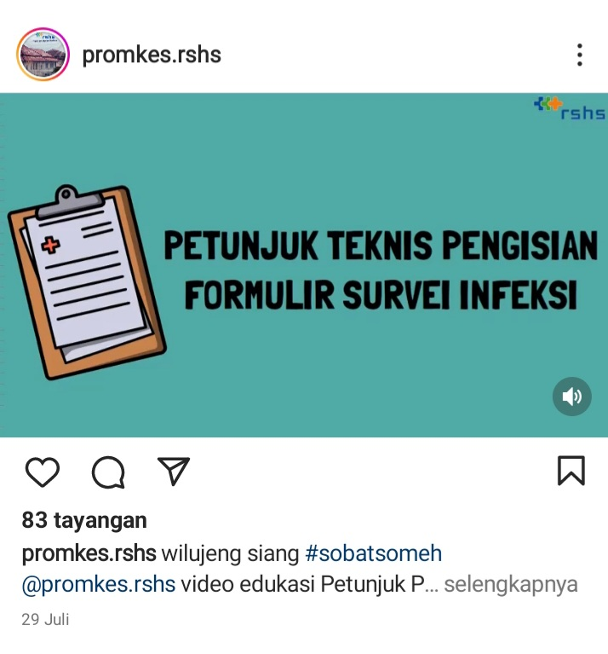
Figure 4: Announcement Content Category
Image Information Health Education Promkes Hasan Sadikin Hospital

The content of the announcement contains educational video technical instructions for filling out the infection survey form in the risk of infection prevention by Rani Dwi Agustin., S.Kep., Nurse, July 29, 2022. The video, which lasts 14 minutes and 55 seconds, provides detailed information about filling instructions and falls into the announcement content category.
Next is an example of an event category on the @promkes.rshs Instagram account:
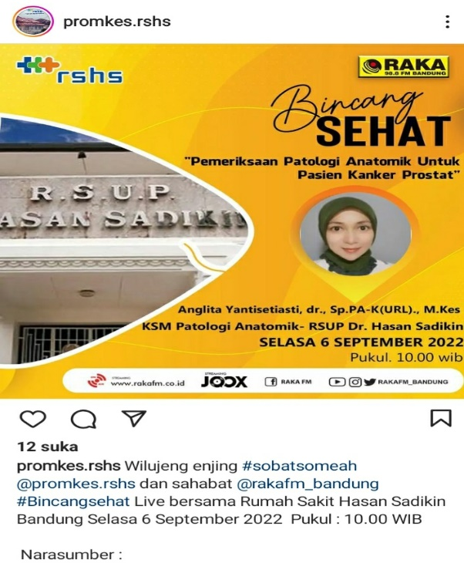
Figure 5: Category Event Content
Health Education Information Health Promotion Hasan Sadikin Hospital

The event content category contains information about talk show events which are held live via YouTube Raka FM Radio, with the source being one of the doctors at Hasan Sadikin Hospital, Bandung. The talk show activity is a collaboration between the Health Promotion Installation of Hasan Sadikin Hospital Bandung and Raka FM Bandung radio. In this activity, listeners can interact and ask questions directly via SMS or WA Radio Raka FM Bandung. This talk show activity with radio is also one of the routine activities carried out by the Health Promotion installation to provide information and education to the public about health.
Next is the health day commemoration content on Instagram @promkes.rshs:
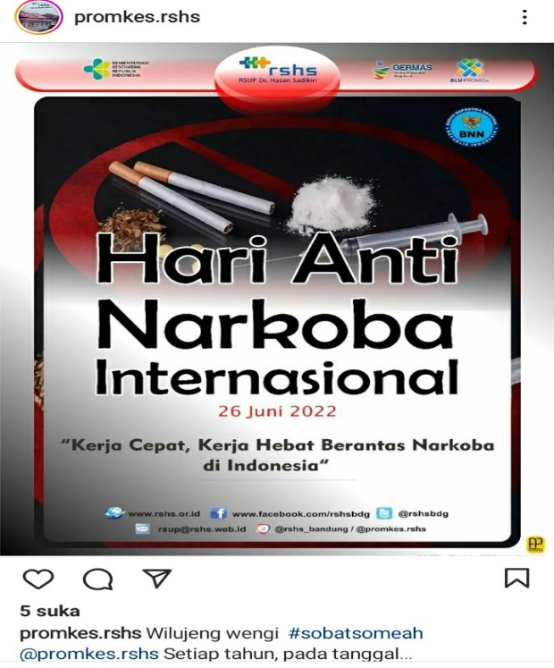
Figure 6: Categories of Health Remembrance Days
Health Education Information Health Promotion Hasan Sadikin Hospital

The Health Remembrance Day content category on the @promkes.rshs account is one of the contents for International Anti-Narcotics Day, which falls on June 26 every year. On that day, the world community stands against the abuse of drugs and the trade in illegal drugs. The commemoration of this day is used by the Hasan Sadikin Hospital Health Promotion Installation as a momentum to increase public awareness, knowledge and understanding of what illegal drugs can cause.
The last content category that is the main focus is health promotion content. An example of content loaded on the @promkes.rshs account is as follows:

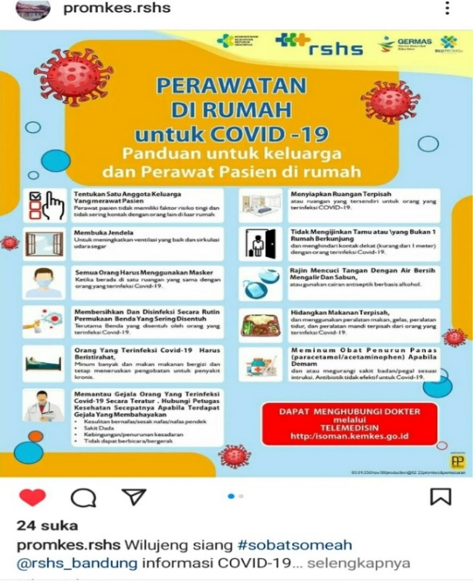
Figure 7: Categories of Health Promotion Content
Health Education Information Health Promotion Hasan Sadikin Hospital

The Health Promotion Content category contains educational information to provide general knowledge and insight to the public. The image above contains guidelines and steps regarding home care for Covid 19 for families and caregivers of patients at home.
The Instagram account @promkes.rshs is active in conveying health information with the four categories presented above. As of August 22, 2022, this account has posted 1085 content with various categories. The type of content that is conveyed is in various forms, such as in the form of posters, pictures, and audio-visual / video. This makes it easier for the target audience to understand better and understand the content conveyed in the social media account.
The effective use of Instagram social media indicates that health promotion officers must be skilled and able to use information and communication technology developments well. This is as conveyed from the results of research [16] that the attitudes and skills of health promotion practitioners, surrounding environmental factors, as well as the attitudes and lifestyle of patients and their families, also greatly support the effectiveness of treatment and care carried out at the hospital. Standard Operational Procedures for Implementing Health Promotion in Hospitals were stipulated in the 2012 Minister of Health Regulations concerning Technical Guidelines for Health Promotion in Hospitals. The Minister of Health clearly explained the importance of health promotion in all non-business hospital units and health workers who work as extension workers or at home in providing health-related education services.
Through Hospital Health Promotion (PKRS), health promoters can develop an understanding and knowledge of healthy visitors, patients and their families regarding health prevention and treatment. In addition, PKRS also seeks to increase awareness and concern for patients, patient families and hospitals. Visitors play an active role in efforts to cure and prevent disease. This proves that PKRS is essential and cannot be separated from hospital services. After all, it supports the growth and development of hospitals because it can improve medical degrees and public health services and make patients, patient families and visitors feel satisfied and comfortable with the service. The hospital of their choice.
The selection of social media as a medium for conveying health information at Hasan Sadikin Hospital in Bandung by the Hospital Health Promotion Installation is one of the health promotion strategies being carried out because hospitals must have a specific strategy for conveying information related to health promotion. The research [17] results show that health promotion aims to socialize health programs to create a new Indonesian society that can live a clean and healthy culture and hope that people can participate directly in health service activities.
Meanwhile, according to the research conducted, the selection of media that the public or patients use states that patient visitors need health messages, as stated by the theory of use and satisfaction, that patient visitors have psychological and social needs that create certain expectations for the media. Any media, including social media, can meet the community's needs because it follows the wishes of patient visitors. Since patient visitors are considered active individuals and patients have goals, they are responsible for choosing the media to meet their needs. These individuals know their needs and how to fulfil them. Media is seen as only one way to satisfy needs, and individuals can use it to meet their needs or choose it in other ways.
In this case, the health promotion installation at Hasan Sadikin Hospital will create an activity program that will use the concept from Rostir, namely by planning by prioritizing the information that is currently needed by the community in general so that health information can add insight and knowledge from patients, families patients and society. Likewise, the evaluation process after each activity is finished, based on the results of an interview with the Head of the Hasa Sadikin Hospital Health Promotion Installation, it is one of the things that must be considered and carried out to improve the quality of the health promotion activities that have been carried out.
Meanwhile, the use of social media in conveying health promotion information is carried out by the Health Promotion installation section because it has several advantages, including being able to reach a wide audience, being able to convey information quickly, being a trusted media, actively posting content through social media will make it easier for the account to grow better. This makes health promoters through the PKRS unit try to provide full service to the community in general so that there is a change in the knowledge and attitudes of patients, patient families and clients towards the various health information provided.
The stage that must be considered in health promotion is evaluating the hospital's health promotion activities. As revealed in the study [19], four indicators are needed to assess the success of PKRS: input, process, output, and impact (Ministry of Health RI, 2012). The criteria for evaluating input indicators are based on (1) whether or not there is a hospital administrator, (2) the presence or absence of all hospital staff or staff, and (3) the presence or absence of a PKRS unit. In the hospital, (4) whether there are officers or staff in the hospital's PKRS unit, (5) does the hospital have rooms and equipment for health promotion, and (6) whether there are sufficient resources for health promotion in the hospital (Ministry of Health Republic of Indonesia 2012).
CONCLUSION
The Instagram account for the Health Promotion Installation @prokes.rshs, belonging to Hasan Sadikin Hospital Bandung, already has a balanced amount of information between health information relating to announcement content, health event content, health warning content and health promotion content. Instagram is one of the social media that is used by health promotion installations to convey health information.
From the results of research [20], social media platforms can be used to disseminate information related to health by utilizing various features. One way is by promoting health, one of which is through advertising features.
The features on social media are utilized by the @promkes.rshs account, namely the upload feature of photos and videos, by adding photo captions, hashtags (#), using IG Story, and IG Live. It is hoped that using these features can further optimize the utilization of Instagram social media.
Things that must be considered to increase the use of social media are determining the specific objectives or goals of the health information to be conveyed, the message or content along with good photo captions to support the message being conveyed, and the timeline or frequency of postings that should be done on a scheduled basis.
ACKNOWLEDGMENTS
Acknowledgements to Padjadjaran University for providing funds in carrying out this research, namely the Unpad Internal Grant research. Unpad and the Unpad Faculty of Communication Sciences have assisted and provided opportunities and permission for the authors to carry out this research. Also, all parties, especially the Head of the Hasan Sadikin Hospital Health Promotion Installation and Health Promotion staff, are willing to provide assistance and convenience.

REFERENCES
[1] Permenkes Number 44 of 2018 concerning the Implementation of Hospital Health Promotion, 2018.
[2] S. Wahyuni and G. Arisani, "The Role of Social Media as a Health Promotion Effort," 2021.
[3] T. and Y. Jasmine, "Editor In Chef/Executor," J. Inov. Researcher. , vol. 1, no. 11, p. 2229–2310, 2021.
[4] RV Insani and JH Nurdan, "Analysis of the Use of Social Media in Hospital Marketing Strategies," Nusant. J. Science. Sauce. , vol. 9, no. 1, pp. 302–308, 2022.
[5] RP Lim, D. Purnomo, and DK Sari, "The Influence of Instagram Users on Instagramxiety Mental Health in Adolescents in Salatiga City," Komuniti J. Komun. and Technol. inf. , vol. 13, no. 1, pp. 47–66, 2021.
[6] FA Sari, NP Sari, and Nabila, "Health Promotion Breast Self Examination (BSE) Using Instagram in Non-Medical Students of Andalas University," Health Media. Mass. Indonesia. , vol. 15, no. 3, pp. 253–263, 2019.
[7] N. Anisah, M. Sartika, and H. Kurniawan, "Use of Social Media Instagram in Increasing Health Literacy in College Students," J. Peurawi Media Kaji. commun. Islam , vol. 4, no. 2, p. 94, 2021.
[8] A. Tri Wijayati, A. Drea, F. Kusumasari, and R. Selvia, " ARSI Journal/Volume 6 Number 3 130 Use of Social Media in Hospitals: A Systematic Review The Use Of Social Media in Hospitals: A Systematic Review," J. ARSI , vol. 6, no. 3, pp. 130–139, 2020.
[9] RSA Suteja, Umar, NSW Wibowo, and D. Ramadhiansyah, "USE OF INSTAGRAM @premature.indonesia AS A MEDIA FOR HEALTH PROMOTION AND PREMATURE PREVENTION," Timeline J. Communal Sciences. , vol. 5, no. 1, pp. 83–105, 2020.
[10] C. Devi, R. Bimatara, AF Lestari, and JDE Sari, "Implementation of Health Promotion (Pkrs) at Fatimah Banyuwangi Islamic Hospital," Ikesma , vol. 14, no. 2, p. 102, 2018.
[11] J. Raco, "Qualitative research methods: types, characteristics and advantages," 2018.
[12] TI Ramadhona, E. Budianti, and NSA Hermawan, "Analysis of Hospital Health Promotion Implementation," J. Ilm. STIKES Kendal , vol. 11, p. 889–896, 2021.
[13] F. Shafitri, F. Fajrini, S. Suherman, and ..., "Description of the Implementation System for Implementing Health Promotion Media at Muhammadiyah Hospital Taman Puring in 2019," J. Kaji. … , vols. 1, no. 004, pp. 185–200, 2021.
[14] L. Vionita and D. Prayoga, "Use of Social Media during the Covid-19 Pandemic in Health Promotion at Tangerang District Hospital," Health Media. Mass. Indonesia. , vol. 20, no. 2, pp. 126–133, 2021.
[15] Ayu Priana, VW Sutjipto, and NA Romli, "The Relationship between the Use of Social Media Instagram @riliv and Meeting Followers' Mental Health Information Needs," Cover. J. Strategy. commun. , vol. 12, no. 2, pp. 85–97, 2022.
[16] MA Suhada and RQ Ain, "Implementation of PKRS in Hospitals Based on Journal Reviews," Muhammadiyah Public Heal. J. , vol. 1, no. 2, pp. 155–17, 2021.
[17] R. Gayatri Setyabudi and M. Dewi, "Analysis of Health Promotion Strategies in the Context of Increasing Awareness of Healthy Living by the Regional Mental Hospital Dr. RM. Soedjarwadi Central Java Province," J. Komun. , vol. 12, no. 1, pp. 81–100, 2017.
[18] BT Husodo and PR Canti, "Media Exposure for Health Promotion with Infection Prevention Knowledge for Hospital Visitors," J. Ilm. commun. Meaning , vol. 6, no. 2, p. 173, 2018.
[19] DPSNSUEHK Salim, "pISSN:2355-7583 | eISSN:2549-4864 http://ejurnalmalahayati.ac.id/index.php/kesehatan," J. Medical Science. and health. , vol. 9, no. 2, pp. 837–843, 2022.
[20] K. Reproduction, R. Pkrr, DI Era, AN Sari, YA Samosir, and AA Pramono, "Youth Reproductive Health Education (Pkrr) in the Era of the Covid-19 Pandemic," no. January, pp. 25–26, 2021.

